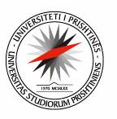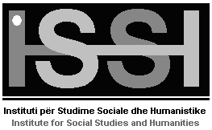

The University Program for Gender Studies and Research
Mission and Objectives

The University Program for Gender Studies and Research at the Institute for Social Studies and Humanities, University of Prishtina, is an innovative space for interdisciplinary academic and gender-based research, teaching, and social involvement. The mission of the Center is to create academic and research programs that inform and sustain global collaborative engagements between students, researchers, and Kosovo’s diverse and interconnected public and private spheres.

The impetus to link these glocal pursuits, is underlined by the Prishtina Principles, and engenders connections with larger regional and global academic communities. We enact a critical approach to the study of femininity, masculinity, and sexuality. The Center encourages, facilitates, and showcases work that addresses the ways in which our economic, social, cultural, scientific, and technical worlds remain profoundly structured by gendered, ethnic, racial, sexual, political, and economic inequality.

Synergizing research with pedagogy and social involvement allows us to better train local and global citizens, and all segments of the work force, with the goal to elaborate a model of citizenship that requires a sustained commitment to social change and equality.

Dr. Nita Luci, Head Steering Committee:

The University Program for Gender Studies and Research MA Linda Gusia
Institute for Social Studies and Humanities #127 Ass. Prof. Hasnije Ilazi
University of Prishtina, Faculty of Philosophy Ass. Prof. Remzije Istrefi
Mother Theresa St. n/n MA Kaltrina Kelmendi
10 000 Prishtina, Kosovo MA Vjollca Krasniqi
E-Mail: nita.luci@uni-pr.edu MA Mimoza Polloshka
Tel.: + 386 (0)49 413 415

Partnership for Change – Empowering Women, an international summit hosted by the President of the Republic of Kosovo, Atifete Jahjaga. October 4-6, 2012.

